Economic Activity of Population in Opolskie Voivodship in the 4th quarter of 2025
Preliminary results of Labour Force Survey in the 4th quarter of 2025
The results of Labour Force Survey (LFS), presenting average data for quarter showed, that in the 4th quarter of 2025 in Opolskie Voivodship economically active persons accounted for 58.1% of population in the age group 15–89 years.
The value of this indicator increased by 1.2 percentage points compared with the previous quarter, however decreased by 1.4 percentage points in relation to the 4th quarter of 2024.
58.1%
Economic activity rate of
persons in the age group 15–89 years in Opolskie Voivodship

Economic activity of population
The number of population in the age group 15–89 years in Opolskie Voivodship in the 4th quarter of 2025 amounted to 742 thousand persons, i.e. less than in the previous quarter and corresponding periods of 2024 as well as 2020 (by 0.1%, and 0.4% as well as 3.6%, respectively). Population of the economically active amounted to 431 thousand persons
(of which 419 thousand employed persons and 12 thousand of unemployed persons).
The number of economically inactive persons amounted to 311 thousand. The population
of the economically active in the 4th quarter of 2025 increased by 8 thousand persons,
i.e. by 1.9% compared to the previous quarter, however decreased: by 12 thousand persons, i.e. by 2.7% and by 6 thousand, i.e. by 1.4%, respectively, in relation to the 4th quarter of 2024 and 2020.
Activity rate of persons in the age group 15–89 years in Opolskie Voivodship in the 4th quarter of 2025 was at the level of 58.1% and its value increased (by 1.2 percentage points)
on a quarterly basis, however decreased (by 1.4 percentage points) on a yearly basis.
Compared with the 4th quarter of 2020 there was an increase of the analysed rate of
1.3 percentage points.
Chart 1. Activity rate of persons in the age group 15–89 years by quarters
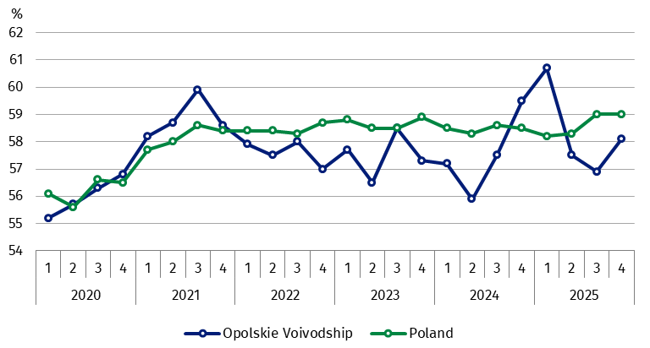

The share of economically active in the total number of persons in the age group 15–89 years in the 4th quarter of 2025 was higher among men and amounted to 67.4%, while in the population of women this percentage was at the level of 49.5%. Considering the place
of residence, said rate was higher among urban inhabitants than rural ones (58.3% versus 57.8%).
Men’s activity rate was higher
than women’s
Taking age groups into account, there was a diverse level of economic activity. The highest value of the activity rate in Opolskie Voivodship occurred in case of persons in the age group 45–54 years (90.8%, i.e. more by 0.9 percentage points in relation to the 3rd quarter of 2025 as well as by 1.1 percentage point compared with the 4th quarter of 2024). The lowest activity rate was recorded among persons in the age group 55–89 years (29.5% – increase on
a quarterly and annual basis, of 2.4 percentage points and of 0.2 percentage points, respectively).
For working age population the measure in question in the 4th quarter of 2025 amounted
to 83.6%, i.e. by 1.0 percentage point more than in the previous quarter, and by 1.1 percentage points less in relation to the 4th quarter of 2024 (in the country – 82.5%,
i.e. on the level of the previous quarter, however more by 0.8 percentage point on an annual basis).
Considering education level, the highest value of the activity rate occurred among persons with a tertiary education (83.2%) and increased compared with the 3rd quarter of 2025
as well as the 4th quarter of 2024 (of 2.6 percentage points and by 1.1 percentage points, respectively). The lowest value was recorded for persons with lower secondary, primary, incomplete primary or no school education and it was on the same level as in the previous quarter, i.e. 20.0%, but it increased on an annual basis by 6.5 percentage points.
The indicator describing relation between unemployed persons (unemployed in the age
15– 74 years or the economically inactive in the age group 15–89 years) to the number
of employed persons (in the age group 15–89 years) decreased on a quarterly basis, however decreased on an annual basis. Compared with the 4th quarter of 2020 its decrease was observed. In Opolskie Voivodship in the 4th quarter of 2025 per 1000 employed persons, there were 771 unemployed persons (in the 3rd quarter of 2025 – 844, in the 4th quarter
of 2024 – 709, and in the 4th quarter of 2020 – 814). In the country this indicator amounted
to 751 (in the 3rd quarter of 2025 – 749, in the 4th quarter of 2024 – 760, and in the 4th quarter of 2020 – 828).

Employed persons
In the 4th quarter of 2025, in Opolskie Voivodship, the population of the employed in the age group 15–89 years amounted to 419 thousand persons and increased by 4.0% (i.e. by 16 thousand persons) on a quarterly basis, however decreased by 3.9% (i.e. by 17 thousand persons) compared with the 4th quarter of 2024 as well as by 1.2% (i.e. by 5 thousand persons) compared with the 4th quarter of 2020.
In the structure of the employed by sex, over a half were men, whose share amounted
to 55.4% (i.e. 232 thousand persons), and by place of residence – urban inhabitants
(53.8%, i.e. 225 thousand persons).
Considering the division by sex, as well as the place of residence, the number of employed persons increased (by 5.6% in the group of women and by 2.7% among men as well as
by 4.9% for rural inhabitants and by 2.7% among urban inhabitants) on a quarterly basis, however decreased (by 7.0% and by 1.3% as well as by 4.5% and by 3.8%, respectively)
on an annual basis.
Taking the age of the employed into account, in the 4th quarter of 2025 the largest share among employed persons was recorded for persons in the age group 45–54 years (27.5%,
i.e. less by 0.2 percentage points than in the 3rd quarter of 2025 and by 0.3 percentage point in relation to the 4th quarter of 2024). The lowest percentage was recorded for the employed in the age group 15–24 years (5.3% – slight increase of 0.1 percentage points on a quarterly basis, and in relation to the 4th quarter of 2024 – on the same level). Persons of working age in the 4th quarter of 2025 accounted for 94.0% of the total number of the employed
(in the 3rd quarter of 2025 – 94.3%, and in the 4th quarter of 2024 – 95.0%).
In the structure of the employed by level of education, in the 4th quarter of 2025 the largest share concerned persons with tertiary education (38.7%, i.e. increase on a quarterly and annual basis, by 0.9 percentage point and by 3.1 percentage points, respectively), while the lowest with lower secondary, primary, incomplete primary or no school education
(4.1% – decrease of 0.4 percentage point on a quarterly basis, however increase of 1.3 percentage points on an annual basis).
The value of employment rate in the 4th quarter of 2025 in Opolskie Voivodship was at the level of 56.5% (in the country – 57.1%) and increased by 2.3 percentage points versus the 3rd quarter of 2025, and decreased by 2.0 percentage point compared with the corresponding period of 2024. Compared with the 4th quarter of 2020 there was an increase of the employment rate of 1.4 percentage points.
Chart 2. Employment rate of persons in the age group 15–89 by quarters
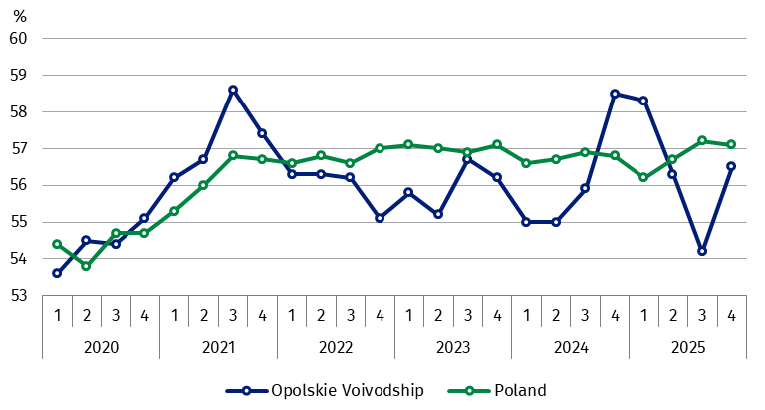

By analysing the population of the employed by sex, a higher employment rate occurred in the voivodship among men (65.2% versus 48.4% for women), and by considering the place
of residence – among urban inhabitants (56.5% versus 56,1% for rural inhabitants).
Employment rate was
significantly higher in the
population of men than of
women
Taking sex into account, in line with the observed tendency, the value of employment rate
increased on a quarterly basis (by 2.5 percentage points) in the group of women as well as (by 1.9 percentage points) among men, and considering the place of residence (by 2.8 percentage points) for rural inhabitants as well as (by 1.6 percentage points) among urban inhabitants. On an annual basis, there was a decrease of employment rate in the analysed groups (of 3.5 percentage points and of 0.6 percentage point, respectively) among women and men as well as (of 2.5 percentage points and by 2.0 percentage points, respectively)
for rural and urban inhabitants.
Value of employment rate for working age population in the voivodship, shaped at the level of 80.9%, i.e. higher by 2.2 percentage points than in the 3rd quarter of 2025 and lower by 2.4 percentage points than in the 4th quarter of 2024 (in the country – 79.8%, i.e. on the level
of the previous quarter, however increase of 0.5 percentage points in relation to the 4th quarter of 2024).
On a quarterly basis among the total number of the employed in Opolskie Voivodship,
there was a decrease in the share of workers employed in public companies/institutions
or by a private employer – of 1.7 percentage points to the level of 81.9% (i.e. 343 thousand persons), and on an annual basis an increase was observed (of 0.9 percentage point). However, the percentage of self-employed persons increased compared with the previous quarter by 1.5 percentage points to the level of 17.4% (i.e. 73 thousand persons), and decreased (by 0.9 percentage point) on an annual basis.
Among persons employed in public companies/institutions or by a private employer, a vast majority performed their work on the basis of a job contract for indefinite term – 82.8%
(i.e. 284 thousand persons). This share increased both on quarterly and annual basis (by 0.6 percentage point and by 2.3 percentage points, respectively).
The largest percentage of the employed in the 4th quarter of 2025 concerned persons, who, during a reference week, worked in the main workplace 40 and more hours (68.5%, i.e. by 1.7 percentage points less than in the previous quarter, and by 5.4 percentage points more than in the 4th quarter of 2024).
In the analysed group of persons, over a half (57.8%) were men; urban inhabitants also had
a larger share (54.4%). Percentage of the employed working part-time shaped at the level
of 9.3% or a group of persons who worked less than 20 hours a week, then 7.9% for the group who worked 20 to 29 hours. Group who worked 30–39 hours a week accounted for 6.0% of the surveyed persons.
Chart 3. Employed persons in the age group 15–89 by selected occupational groups
in the 4th quarter
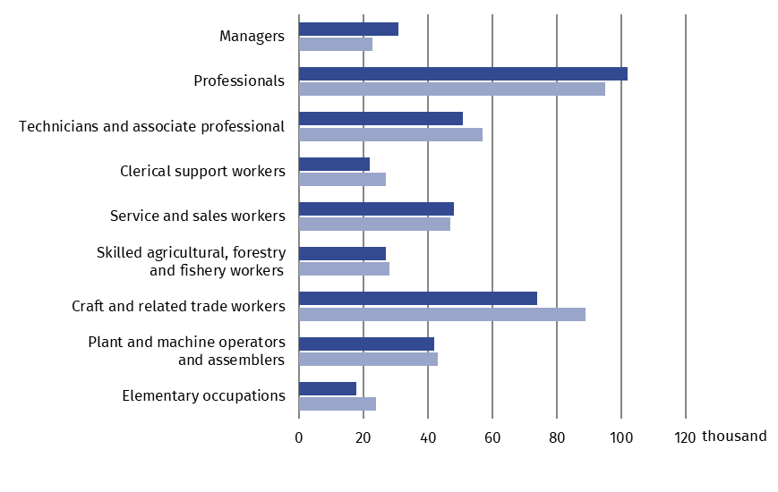

2025 2024

In the 4th quarter of 2025 the most persons were employed in the profession from the group of professionals (102 thousand) and accounted for 24.3% of all employed persons. Among women, share for this occupational group amounted to 33.7% and was higher by 0.9 percentage point than in the previous quarter as well as by 3.4 percentage points
compared with the 4th quarter of 2024. A significant share in the population of women was held by group service and sales workers – 18.7% (percentage decreased on a quarterly basis by 1.1 percentage points, and increased by 1.8 percentage points on an annual basis). Among men the most persons worked in occupational group of craft and related trade workers (27.6% – decrease in relation to the 3rd quarter of 2025 as well as the 4th quarter of 2024
by 5.6 percentage points and by 6.0 percentage point, respectively), and then in the group
of professionals (17.2%, i.e. more by 2.2 percentage points on a quarterly basis and
by 2.7 percentage points on an annual basis).

Unemployed persons
In the 4th quarter of 2025 , population of the unemployed in the age group 15–74 years
in Opolskie Voivodship amounted to 12 thousand and decreased by 40.0% (i.e. by 8 thousand persons) compared with the previous quarter.
Unemployed persons in the 4th quarter of 2025 constituted 2.8% of economically active persons in the age group 15–89 years and this share decrease on a quarterly basis by 1.9 percentage points (in the country – 3.2% and a slight increase of 0.1 percentage points).
An average time of seeking job in discussed period in Opolskie Voivodship, similarly
as in the country, was longer than in the 3rd quarter of 2025 and amounted to 10.3 month versus 8.3 month (in the country – 8.6 versus 7.9).

Economically inactive persons
The population of the economically inactive in the age 15–89 years in the 4th quarter 2025,
in Opolskie Voivodship accounted for 311 thousand persons, i.e. 41.9% of the total number
of persons in the said age group (versus 41.0% – in the country). Analysed population number decreased (by 2.8%) compared to the previous quarter, and increased (by 3.0%) versus the 4th quarter of 2024. Compared with the 4th quarter of 2020 there was a decrease in the number of economically inactive persons (by 6.6%).
Over a half of economically inactive persons are women – 62.7%, i.e. 195 thousand persons. Considering the place of residence, urban inhabitants constituted 53.4% of this population (i.e. 166 thousand persons).
Over a half of economically
inactive persons were women
In terms of sex, the number of economically inactive men decreased on a quarterly basis
by 4.1%, and women by 2.0%. On the other hand, compared to the 4th quarter of 2024 the number of economically inactive women increased (by 5.4%), and in the case of men
it remained on the same level.
Chart 4. Economically inactive persons aged 15–89 years by sex and place of residence
as well as quarters
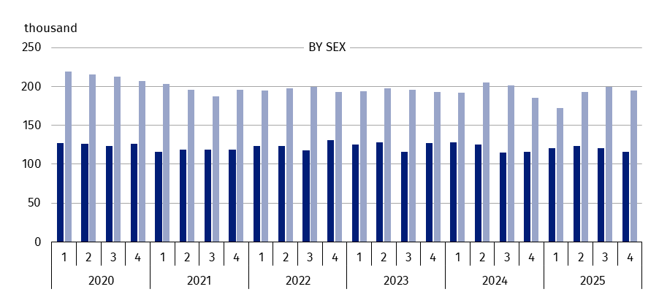

Men Women

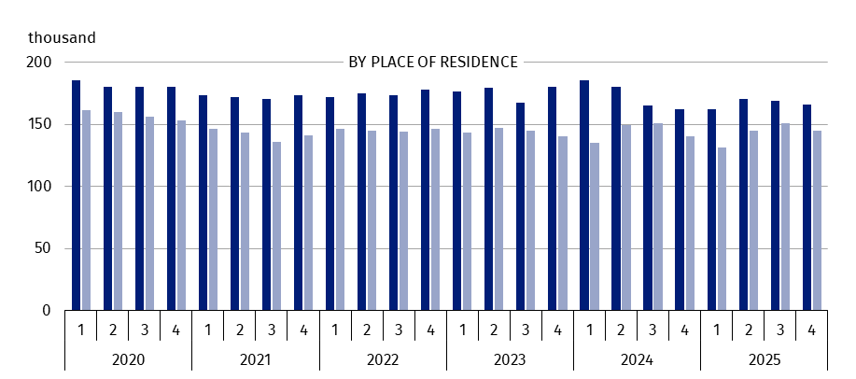

Urban areas Rural areas

Considering place of residence, on quarterly basis, the number of economically inactive rural, as well as urban inhabitants, decreased (by 4.0% and by 1.8%, respectively), and
on an annual basis in both groups there was an increase (by 3.6% and by 2.5%, respectively).
Out of economically inactive in the voivodship, 81 thousand persons, i.e. 26.0% were
of working age. Economically inactive persons mostly had basic vocational/sectoral education (27.3%) as well as lower secondary, primary, incomplete primary or no school education (27.0%).
The main reason for the inactivity of economically inactive persons in the age group 15–74 years (for this group a cause for inactivity was determined), amounting to 239 thousand was retirement – 53.6%. Among persons receiving pension 63.6% were women.
Education and training were the reasons for work inactivity and not seeking job in the 4th quarter of 2025 for 22.2% of economically inactive persons. Illness or disability as a reason for economic inactivity was reported by 7.1% persons, while family and household responsibilities – 6.3% of the economically inactive persons from the discussed age group.

Table 1. Economic activity of the population aged 15-89 in Opolskie Voivodship compared
to the country
SPECIFICATION | 2020 | 2024 | 2025
SPECIFICATION | 4th quarter |  | 3rd quarter | 4th quarter
POLAND
Economically active in thousand | 17365 | 17742 | 17923 | 17912
employed | 16819 | 17247 | 17361 | 17346
unemployedª | 547 | 495 | 562 | 567
Economically inactive in thousand | 13372 | 12610 | 12440 | 12456
Activity rate in % | 56.5 | 58.5 | 59.0 | 59.0
Employment rate in % | 54.7 | 56.8 | 57.2 | 57.1
Unemployment rate in % | 3.2 | 2.8 | 3.1 | 3.2
OPOLSKIE VOIVODSHIP
Economically active in thousand | 437 | 443 | 423 | 431
employed | 424 | 436 | 403 | 419
unemployedª | 12 | . | 20 | 12
Economically inactive in thousand | 333 | 302 | 320 | 311
Activity rate in % | 56.8 | 59.5 | 56.9 | 58.1
Employment rate in % | 55.1 | 58.5 | 54.2 | 56.5
Unemployment rate in % | 2.7 | . | 4.7 | 2.8
a Persons aged 15–74 years.

Table 2. Activity rate in the age group 15-89 by sex, place of residence and age groups
SPECIFICATION | 2020 | 2024 | 2025
SPECIFICATION | 4th quarter |  | 3rd quarter | 4th quarter
SPECIFICATION | w %
T O T A L | 56.8 | 59.5 | 56.9 | 58.1
Of which of working ageª | 79.1 | 84.7 | 82.6 | 83.6
men | 65.7 | 67.5 | 66.1 | 67.4
women | 48.3 | 52.2 | 48.4 | 49.5
Urban areas | 56.7 | 59.5 | 57.4 | 58.3
Rural areas | 56.5 | 59.4 | 55.9 | 57.8
By age:
15–24 years | 33.3 | 32.1 | 28.4 | 30.9
25–34 | 85.3 | 92.8 | 87.6 | 86.7
35–44 | 87.9 | 88.1 | 89.2 | 89.0
45–54 | 86.2 | 89.7 | 89.9 | 90.8
55–89 years | . | 29.3 | 27.1 | 29.5
a Men 18–64 years; women 18–59 years.

Table 3. Employment rate in the age group 15-89 by sex, place of residence and age groups
SPECIFICATION | 2020 | 2024 | 2025
SPECIFICATION | 4th quarter |  | 3rd quarter | 4th quarter
SPECIFICATION | in %
T O T A L | 55.1 | 58.5 | 54.2 | 56.5
of which of working ageª | . | 83.3 | 78.7 | 80.9
men | 64.3 | 65.8 | 63.3 | 65.2
women | 46.5 | 51.9 | 45.9 | 48.4
Urban areas | 55.5 | 58.5 | 54.9 | 56.5
Rural areas | 54.8 | 58.6 | 53.3 | 56.1
By age:
15–24 years | 31.0 | 28.4 | 25.9 | 27.2
25–34 | 81.0 | 91.8 | 81.4 | 82.7
35–44 | 86.4 | 88.1 | 86.2 | 86.6
45–54 | 83.7 | 89.0 | 86.8 | 88.5
55–89 years | 25.7 | 28.6 | 26.1 | 29.5
a Men 18–64 years; women 18–59 years.

Note. LFS results refer to the population residing or intending to stay in the country for at least 12 months, living in households. Data collected in representative survey up to 3rd quarter of 2023 have been generalised to the general population with the use of balances prepared on the basis of the results of National Housing and Population Census 2011. Since 4th quarter of 2023, as to generalise the survey results to general population, data on the resident population from the balances prepared on the basis of National Housing and Population Census 2021 results were used. Data for the period from 1st quarter of 2019 to the 3rd quarter
of 2023 were calculated in accordance with the new basis for generalising the results, therefore they are comparable.
In the study, the sums of components may differ from the "total" value, which is the result of rounding made when generalising the survey results. Due to the representative survey method, caution is recommended
in the use of data in those cases where more detailed divisions are used and there are low-order numbers (less than 20 thousand). Numbers which, after generalising the results from the sample, are below 10 thousand have been replaced with a dot ("·"), which means that a specific value cannot be shown due to a random sample error.
When citing data from the Statistics Poland please provide the following information: "Statistics Poland`s data". When publishing calculations made on data published by the Statistics Poland, please provide the following information: "Own study based on the Statistics Poland's data”




opole.stat.gov.pl
Prepared by:
Statistical Office in Opole
Director Renata Wasilewska
Phone: 77 453 14 52
Issued by:
Opolski Centre for Regional Surveys
Statistical Information Centre
Phone: 77 423 10 00, 510 993 218
@Opole_STAT
Media management:
Hanna Sterniuk-Mościcka
Opolski Centre for Regional Surveys
Phone: 514 901 001
e-mail: h.sterniuk-moscicka@stat.gov.pl
@USOpole

Related information
Economic Activity of Population in Opolskie Voivodship in the 3rd quarter of 2025
Employed, unemployed and economically inactive persons (preliminary results of the Polish Labour Force Survey in the 4th quarter of 2025)

Data available in databases
Local Data Bank -> Labour market

Terms used in official statistics
Economic activity by LFS
Activity rate by LFS
Employment rate by LFS
Unemployment rate by LFS

